REQUEST TO CONDUCT A RESEARCH ACTIVITY IN DOÑANA NATURAL AREA (Nº ………………)

REQUIRED DOCUMENTATION
- This completed research request form in WORD format (don’t erase any of its content)
- Approval of the project by the funding entity or link to resolution
- Research proposal (original proposal or an executive summary including 1.- Introduction and justification 2.- Specific aims 3.- Potential contributions of the project to nature conservation 4.- Material and methods 5.- Precise study area 6.- Potential impact of project on the environment 7.- Study period 8.- Participants (number and identification) 9.- Budget and financial support 10.- Bibliographic references; total length 2-3 pages)
Send to coordinacion@ebd.csic.es at least 2 month ahead. If the documentation is presented by another member of the research team, the responsible researcher must be included in the email

Project Title:

Scientist in charge/Coordinator:
ORCID CODE (or other research ID):
Institution and Address:
Email:
Tel.:

Principle participants
Family name(s), name | DNI/Passport | Gender M/F | Institution | Research Position/role in the project
 |  |  |  | Scientist in charge/Coordinator

Other participants (companion of principle participants)
Family name(s), name | DNI/Passport | Gender M/F | Institution | Research Position/role in the project

In case you require support for data collection (samples, observations, guiding) of the Monitoring Team of Natural Processes of the Doñana Biological Station, fill out this form:

Name and mobile of responsible for field work:

Indicate vehicle brand, type and colour, and plate number:

ABSTRACT OF THE RESEARCH PROPOSAL:

DURATION OF THE PROJECT (d/m/y-d/m/y):

DURATION OF THE FIELD WORK (IF DIFFERENT)

FUNDING ENTITY AND CALL IDENTIFICATION (provide link or document):
Total budget:
Estimate specific budget for Doñana (if different from total):

GEOGRAPHIC DELIMITATION STUDY AREA (Describe in text format and indicate on the map):

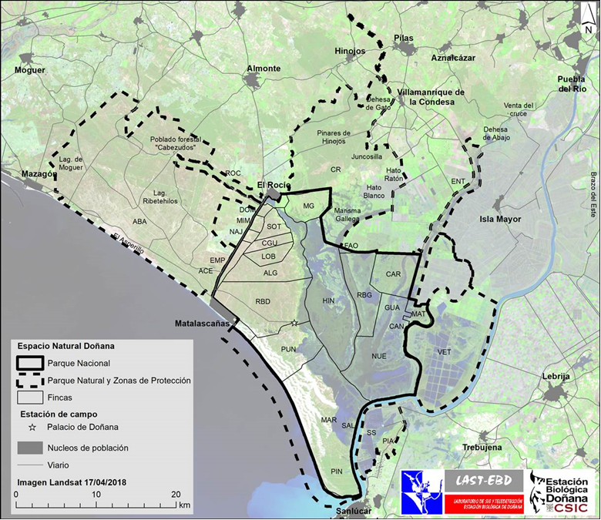
ABA Abalario; ACE El Acebuche; ALG Algaida; BRT Brazo de la Torre; CAN El Cangrejo; CAR Caracoles; CGU Casa del Guarda; CR Coto del Rey; DOM Eucalitpal de Domec; EMP Empetrol; ENT Entremuros; FAO Parecel FAO; GUA Marismas del Guadiamar; HIN Marisma de Hinojos; LOB El Lobo; MAR Marismillas; MAT Matochal; MG Matasgordas; MIM Los Mimbrales; NAJ Najarsa; NUE Las Nuevas; PLA Playa; PIN Pinar del Faro; PUN El Puntal; RBD Reserva Biol Doñana; RBG Reserva Biol Guadiamar; ROC La Rocina; SAL Salinas; SOT Los Sotos; SS Salinas Sanlucar; VET Veta la Palma

Field period proposed for a standard year:
Month: | e | f | m | a | m | j | j | a | s | o | n | d
Nº field days
Nº maximum persons/day
Nº maximum vehicles/day
Lodging in field station (yes/no)¹⁾
¹⁾ Possibility of lodging in one of the field stations depends on availability at each moment.

DEFINITION OF SAMPLES, ANIMAL CAPTURING, USE OF TAGS OR DEMARCATIONS, AND INSTALLATION OF FIELD EQUIPMENT (Indicate below).

If none of the above is the case, please confirm here:

PROGRAMMED CAPTURE OR HANDLING OF FLORA AND FAUNA SPECIMENS*
Species | Number individuals | Captures/year | Area | Period/Frecuency

SAMPLES TO BE COLLECTED
Type/Tissue | Sample number | Sample No/year | Area | Period/ Frecuency

USE OF LARGE EQUIPMENT, INSTALLATION OF PERMANENT DEVICES, MARKS OR OTHER DEVICES (eg. Machinery, drones, fences..)
Kind/type | Number | Number/year | Area | Term (m/y-m/y) or period/frecuency

Shortly describe the capture, sampling and/or field work procedures:

Once the project is approved, the Coordination of Research Service will apply for the required authorization for access to the protected area, and also, if necessary, for sampling and capturing protected species at the regional authority for environmental conservation.

If required, the researcher in charge should present an authorization for animal experimentation (https://www.juntadeandalucia.es/servicios/procedimientos/detalle/12572.html).

The scientist in charge of the project promises to communicate the precise location (if possible in Geographic Projection System (WGS84 Datum) or in UTM coordinates indicating Datum and Zone) of equipment, signals, study areas, etc. to the Coordination of Research Service (in order to avoid interactions between projects and management activities in the Natural Area) and, when it is the case, to remove all features once the project is finished leaving the area in the same state as before.

At the end of each year a summary of the results should be provided to be included in the Annual Report on Research in the Doñana Natural Area. Additionally, once the project is finished, you are kindly request to send all publications produced (final report, publications, conferences, dissertations, etc.) to coordinacion@ebd.csic.es.

In any publication derived from this project (publication, reports, conferences), you should acknowledge the support received from our Large Scale infrastructure ICTS-RBD (Singular Scientific Technical Installation of the Doñana Biological Reserve). Thank you for your collaboration

CONTACT:
Oficina de Coordinación de la Investigación
Estación Biológica de Doñana
c/ Américo Vespucio, 26
41092 Sevilla
Teléfono: 954232340/954466700 (direct 955149294/95)
e-mail:coordinacion@ebd.csic.es

