MEETING REDIAM-CSIC
Temporal trends of stone and cork oak forest in Andalusia

Time: May 17, 2016
Location: Rediam headquarters, Johan G. Gutenberg 1. 41092. Seville
Participants: Yolanda Gil, Clint García, Eloy Revilla, and Carlos Rodriguez
Author: Revilla, E. Garcia, A. and Rodriguez. C

Introduction
During the WP2-WP5 joint meeting held in Seville on 27-29 April 2016, a session was dedicated to discuss on the interlinks between the Environmental information network of Andalusia (REDIAM) and the EU BON project. In this fruitful discussion, regional information on land uses and, especially the information regarding the Quercus spp present in the area were selected as potential for this use-case. At that time, several technical details were not available and this meeting was organized to better define the use-case, and understand the potential challenges to be found when dealing with data. Moreover, some technical details on how to deal with information from REDIAM were also retrieved from the IT people in the Doñana Biological Station prior to write this summary

Aim
Generate a product that is new and offers added value to the potential users (managers and public in general). Using methods developed witihin the Eubon project
The product focus on tree species of economic and environmental relevance in the southwest of Europe: stone and cork oaks (Quercus rotundifolia & Quercus suber)
The different steps defined below will use the techniques and methods developed in WP2
- Show maps for a selected time window
- Show areas of change in the map (distinguishing losses from gains) between two periods
- Generate a table with values
- Select a subzone to show and extract information
Depending on the particular product to be generated, several possibilities arise:
- In case of needing to represent raw data over maps (OGC Web Map Services, hereafter WMS), CartoDB manages to represent a single WMS layer as base map, and datasets (CSV, KML, Shapefiles) as data layers, represented on top of the basemap.
- In case of needing layer based operations, a different software toolkit would be required. The EU BON WP2 team has identified the need of representing different layers on maps, giving the user the ability of selecting layers and even perform some operations over them. As result of this initial analysis, the team has proposed several alternatives:
- Develop a specific tool able to retrieve more complex products than just WMS (e.g. web coverage services -wcs-, web coverage processing services -wcps-, or web feature services -wfs-). Such a tool should be able of representing all these products, hereafter grouped as “WxS layers” and perform basic GIS operations. Leaflet.js and OpenLayers could be used to develop the tool.
- Use an open source/free software tool with the ability of representing and performing analytical operations over WxS layers. For instance 52north (http://52north.org/). Particular analyses would be created as web processing services (WPS), WCPS or similar.
- As an alternative, GEO is developing a new GEO Portal and created a new component for representing the layers. We will ask the GEO Community Portals team about this component in order to have access to it and, if feasible, apply it to both the REDIAM use case and the EU BON Biodiversity portal.

Changes in land cover of stone and cork oaks in Andalusia
Using SIOSE-A (land cover changes in Andalucía, since 1956), it is possible to identify land cover types associated with the two target species. A further reclassification would simplify the classification into few classes (maybe dehesas and Mediterranean forest) depending on tree density.
SIOSE-A layers are published as WMS services. CartoDB manages to use WMS layers as base map, but only one at a time. An example of this capability is illustrated in Figure 1, showing a CartoDB map with a SIOSE-A WMS layer with the Quercus genus coverage in Andalusia as base map.
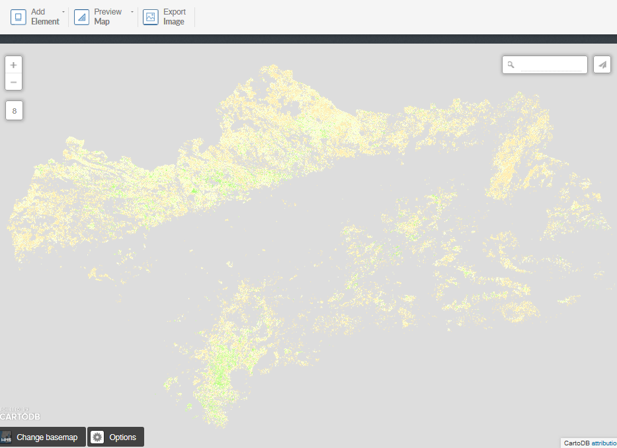
Figure 1. Quercus coverage using a SIOSE-A WMS base map

Because information on this is available since 1956, a dynamic map would show temporal changes in Quercus cover during the past 60 years. Such a map would show which areas have been occupied recently by the species, and from which areas they are dissapearing. Basic statistics of the process would be also given as additional information. Nonetheless, overlapping different layers (i.e. using more than just 1 WMS at a time), would need more advanced GIS tools, but further analysis on this matter is required to properly report on that.
On this basic proposal it is possible to build more advance products. Some of them are shown below as examples:
Potential product 1.- Evaluation of Pressures
Once trends in cover has been described, advancing on the potential factors explaining why the species diminish or even dissapear from some areas could be identified. For this purpose, landuses from the SIOSE-A could be reclassified as potential pressures: urbanization (using all landuses identified as urban), conversion into arable land (using all landuses identified as agriculture), and burning (using the information on fires that REDIAM retrieves on a regional scale)
As mentioned before, intersecting different layers would need to use GIS tools with more capabilities than CartoDB. Further analysis of this matter is required.

Potential product 2.- Conservation status of the forest
By using information from the National Forest Inventory, it is possible to know the conservation status of the forest patch. This information could be merged with information on landuses as an interpolation or heat map showing how healthy are the different oak forest within the region. Further information from a forester is required to better define this product.
CartoDB manages to created heat maps, but only in case of managing raw data sets directly. In case of using GIS layers, the use case would be similar to the main product described above, that is, working with GIS layers using open source tools and creating OGC based services to be offered.

Potential product 3.- The habitats directive
Both protected areas and habitats of conservation concern could be also spatially represented to illustrate to what extent such habitats are being properly protected by the current network of protected areas. As a matter of fact, additional GIS processing would be needed.

